**IOT**

**PHASE- 4 : DEVELOPMENT PART 2**

**PROJECT: ENVIRONMENTAL MONITORING**

**PLATFORM DEVELOPMENT:**

* This website is designed to deliver real-time data and recommendations for park visitors. The webpage structure includes essential components such as navigation, informative content, and social media links.
* The webpage incorporates a responsive navigation menu that allows users to explore different sections of the website. Clicking the menu icon reveals the menu, and clicking the "x" icon hides it, making it suitable for mobile devices.
* The site's main content section highlights the features it offers, emphasizing the monitoring of crucial environmental parameters. These include temperature, humidity, infrared motion detection, and light-dependent resistor (LDR) sensors for efficient park lighting. These features aim to enhance the safety, comfort, and overall experience of park-goers.

**STEP 1: HTML Coding**

STEP 1.1: Creation of Index page

The below code provides the structural framework for the environmental monitoring website.

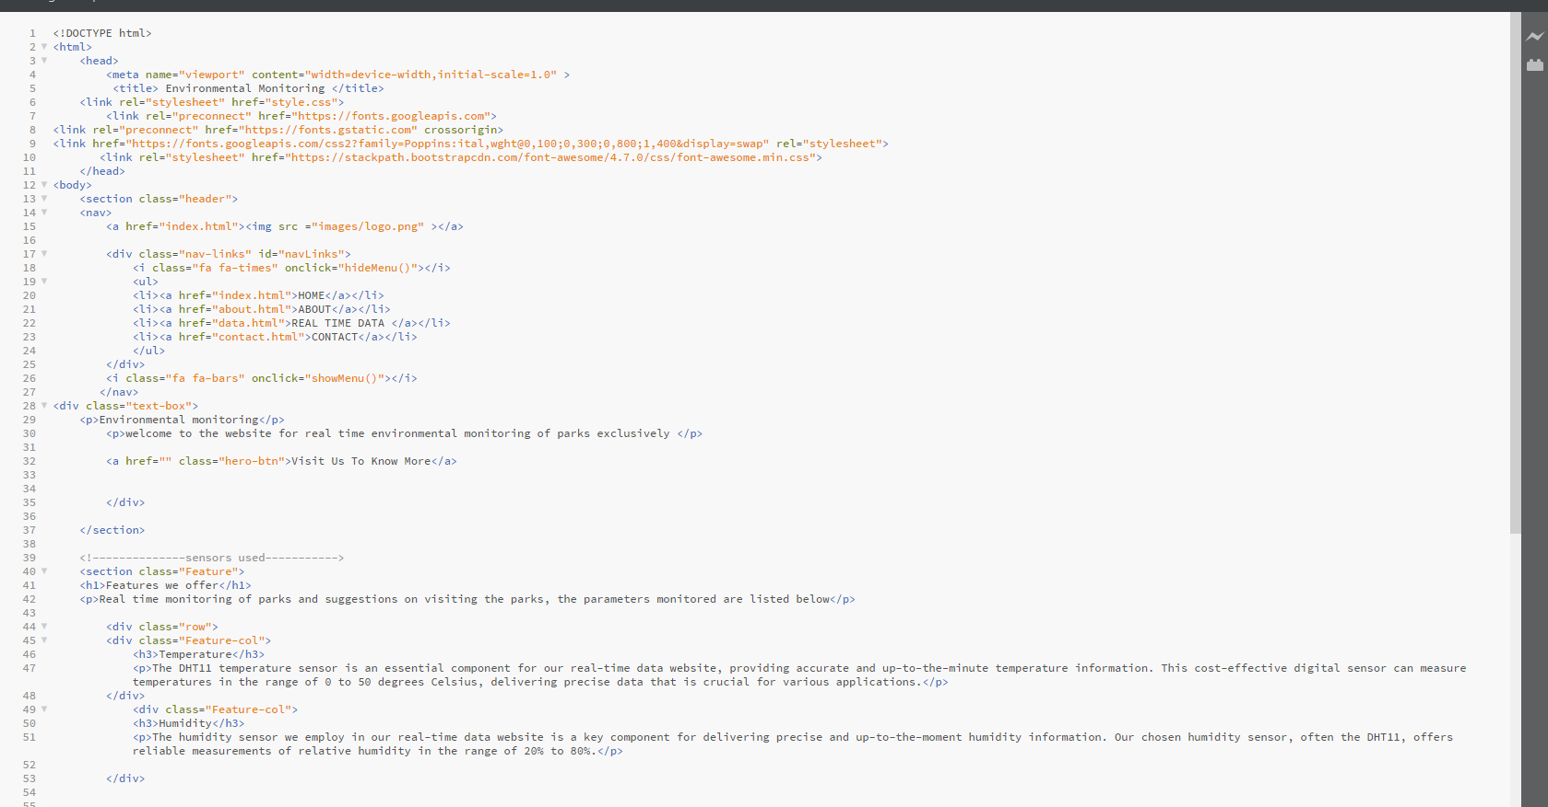

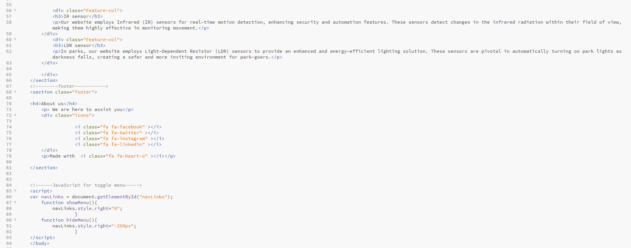

STEP 1.2: Creation of ‘About’ page

The main content of the webpage is structured into several sections. It has a navigation menu at the top, which includes links to the homepage ("HOME"), an "ABOUT" page, a "REAL TIME DATA" page, and a "CONTACT" page. The menu is designed to be responsive for mobile devices, allowing users to toggle it on and off.

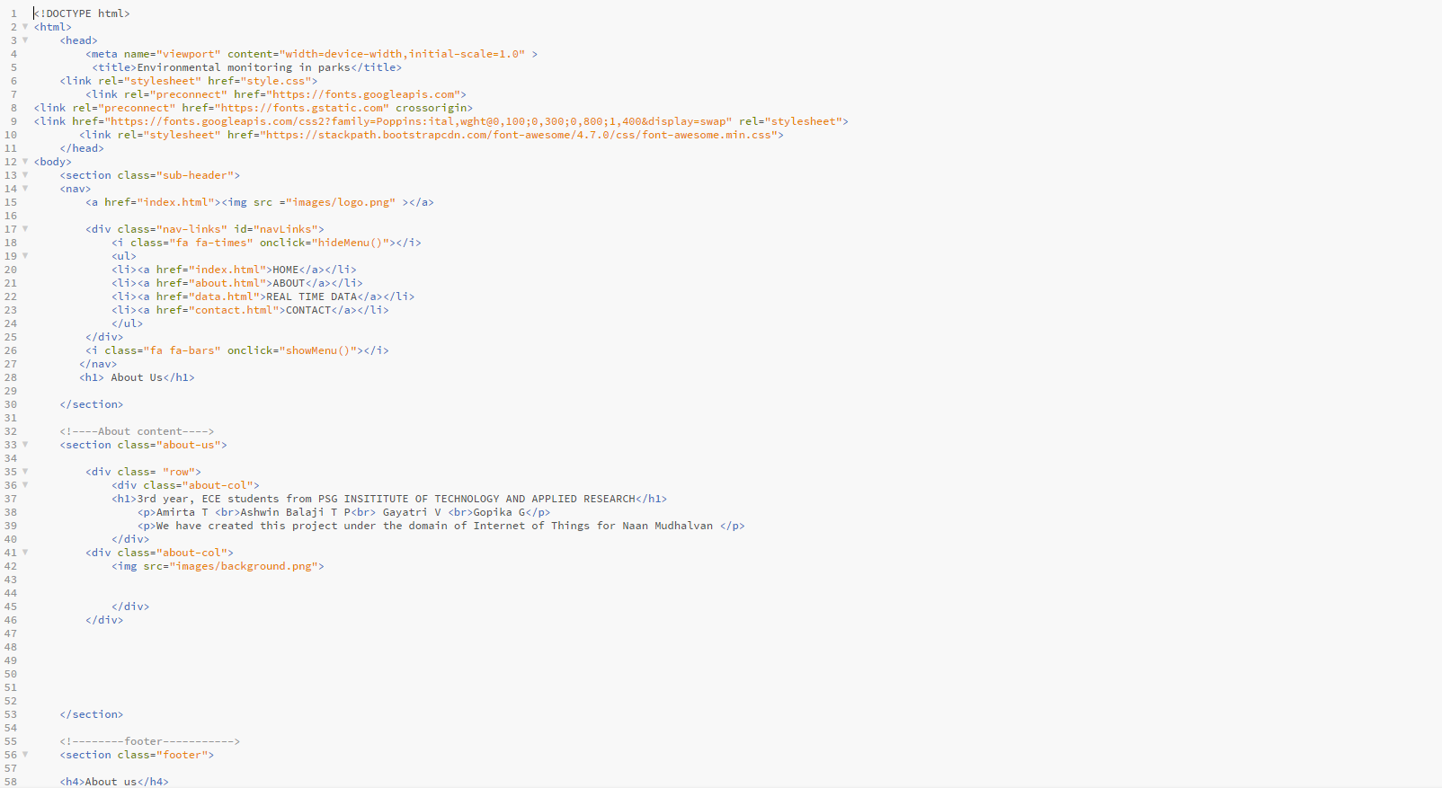

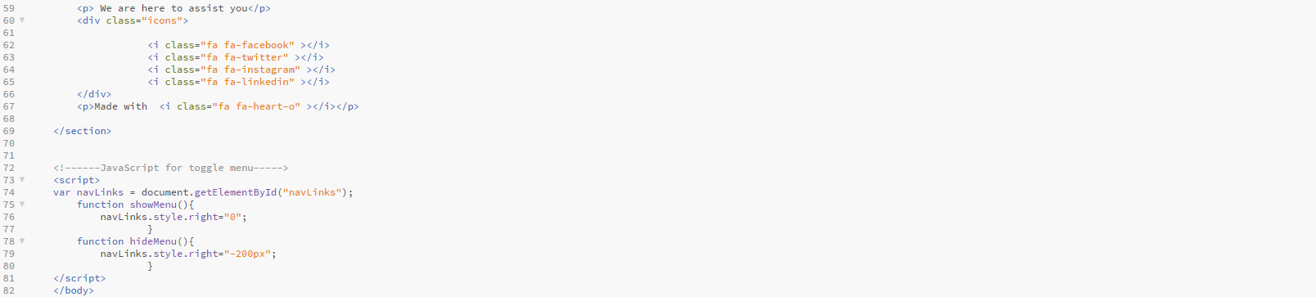

STEP 1.3: Creation of ‘REAL TIME DATA’ page

The below code represents a webpage dedicated to "Real Time Data"

In the context of environmental monitoring in parks The "Real Time Data" page, in particular, focuses on providing information about the project's features and the Environmental Monitoring System. It highlights the use of advanced sensors, such as the DHT11 for temperature and humidity, a PIR sensor for motion detection, and an LDR sensor for assessing light levels. These sensors work together to offer real-time data through the Wokwi platform, enabling immediate access to essential environmental information about the parks.

The project's goal is to enhance the park experience by optimizing conditions, ensuring visitor comfort, improving security, and facilitating data-driven decisions. The website's user-friendly interface offers real-time updates, historical records, and alert notifications for a superior park experience.

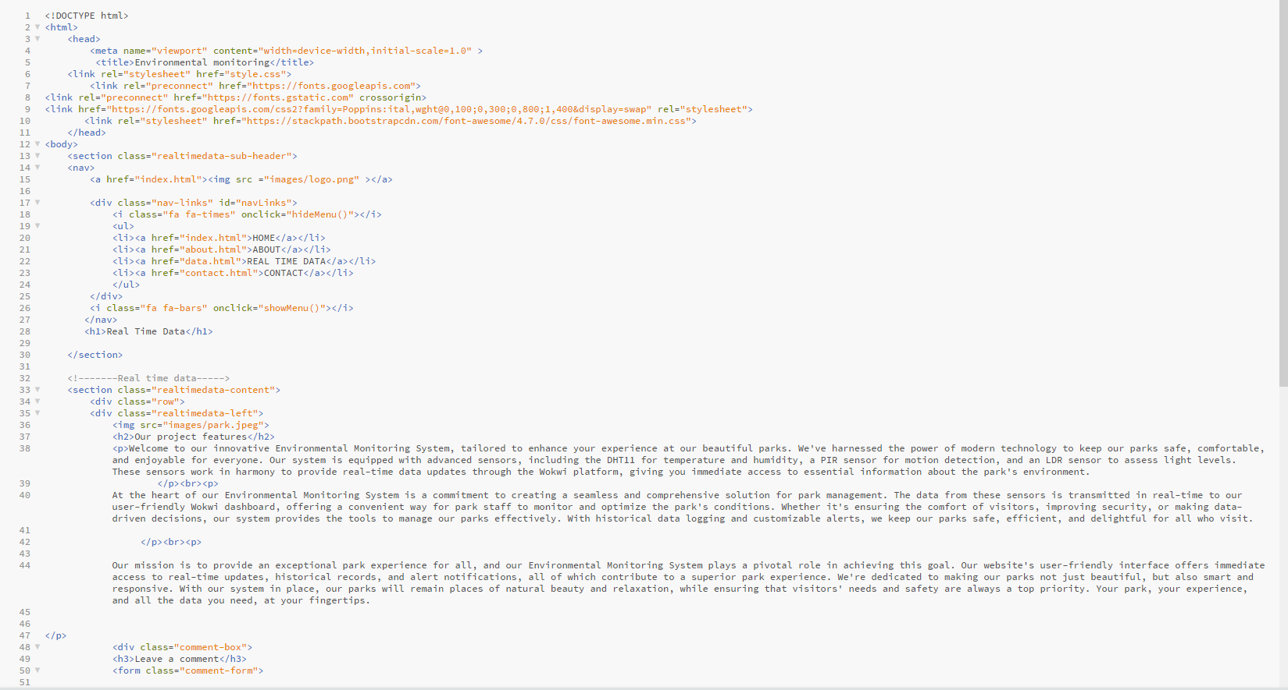

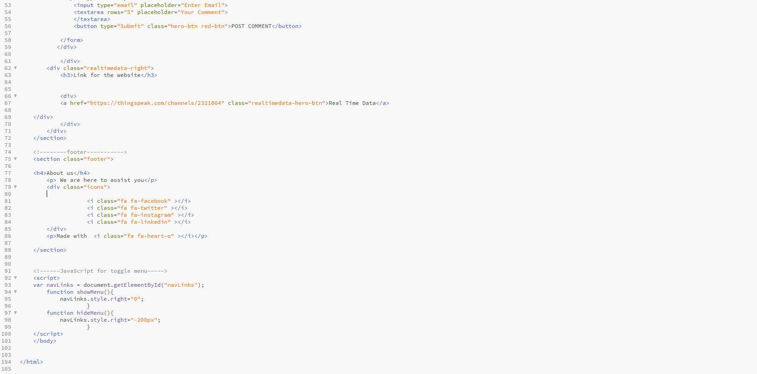

STEP 1.4: Creation of ‘CONTACT’ page

The "contact-us" section is divided into two columns. The left column displays contact information, including the institute's address, phone number, and email address. Users can find details on how to reach out and when to expect a response.

The right column contains a contact form that allows users to send messages. It includes fields for the user's name, email address, subject, and a message. Users can enter their details and message, then click the "SEND MESSAGE" button to submit their inquiries or comments.

The "footer" section offers a brief message stating that the website is here to assist users. It also provides icons for various social media platforms (Facebook, Twitter, Instagram, and LinkedIn) to encourage engagement and interaction with the project.

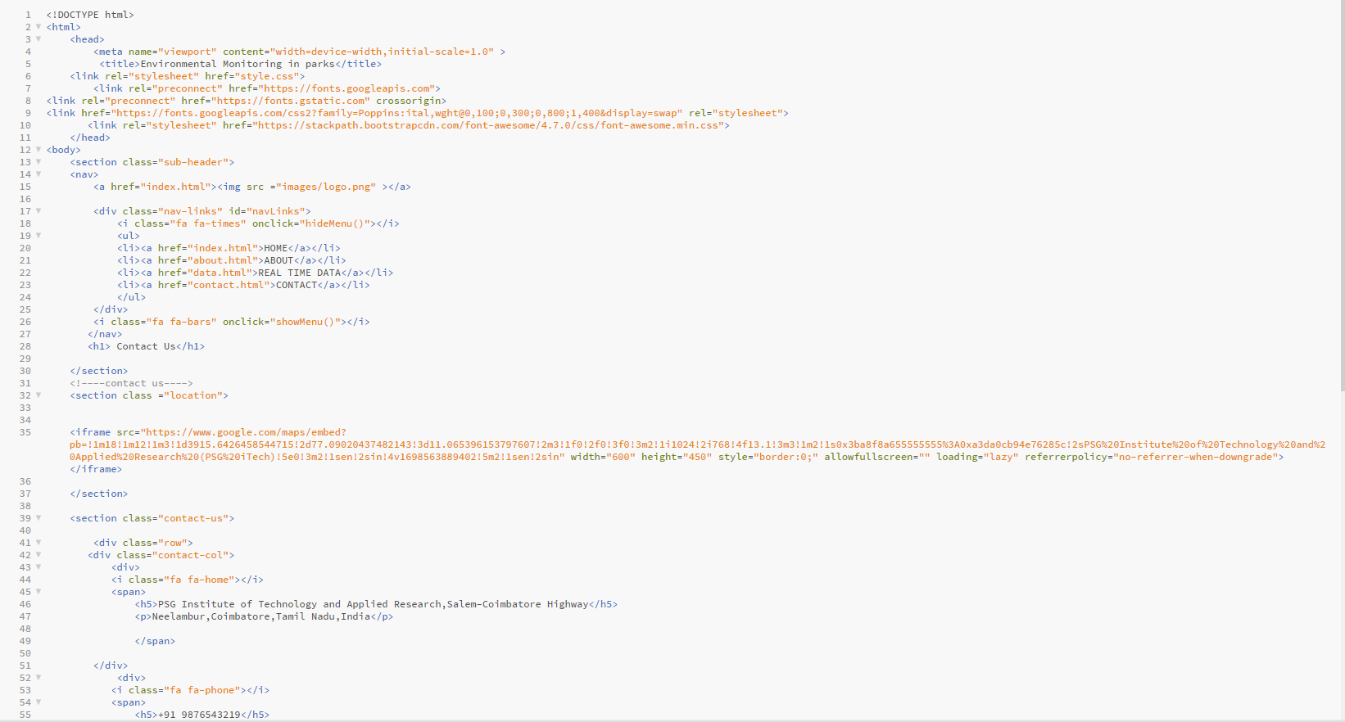

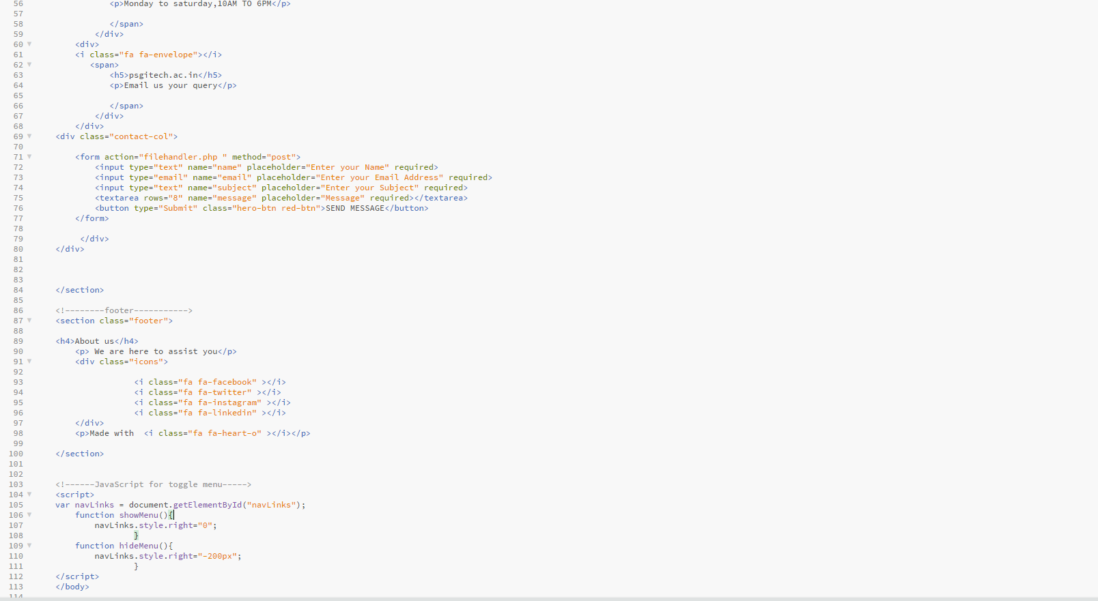

**STEP 2: CSS CODING**

The below code is a CSS stylesheet that defines the styling and layout of our webpage. It covers the header, navigation, feature sections, footer, "About Us" page, real-time data section, comment boxes, and "Contact Us" page. It also includes responsive design features to adapt the layout for smaller screens, making it suitable for various devices and screen sizes.

. It includes various sections, each with specific styles.

Explanation of what various parts of the code:

1. Universal Styles: The code begins with universal styles for all elements. It sets the margin and padding to zero for all elements, and it specifies the font family as 'Poppins' for a clean and modern look.

2. Header Styles: The code defines styles of our website's header, which occupies the full viewport height (100vh). It includes a background image and styling for the navigation menu. The navigation menu elements are horizontally aligned and positioned on the right.

3. Navigation Styles: These styles apply to the navigation menu within the header. It includes styling for the logo, navigation links, and their hover effects. The navigation links have an underline animation upon hover.

4. Text Box Styles: These styles apply to a text box within the header, which is used for displaying a title and description. It's positioned in the centre of the header and styled with a large title and smaller description text. Additionally, it defines styles for a call-to-action button (hero-btn).

5. Media Query for Responsive Design: The code includes a media query that triggers when the screen width is less than 700px. In this case, the navigation links are hidden, and a "hamburger" icon (represented by `.fa`) is displayed. Clicking on the icon reveals the navigation links in a vertical layout.

6. Feature Section Styles: These styles apply to a section of the webpage dedicated to features. It defines the background image, text color, and padding. The section includes styling for headings and paragraphs.

7.Feature Column Styles: The code specifies styles for columns within the feature section. These columns have a background color, padding, and a slight opacity, giving them a card-like appearance. The text and headings inside these columns are styled, and they have a hover effect that adds a shadow when hovered over. There's also a media query to stack the columns on top of each other for smaller screens.

8. Footer Styles: These styles are applied to the footer section of the webpage. It defines the background image, text colour, and padding. The footer includes styles for headings and paragraphs.

9. About Page Styles: The code defines styles for an "About Us" page section. It sets the background image, text colour, and padding for this section. The "sub-header" style handles the header of the "About Us" page.

10. Real-Time Data Section Styles: Similar to the "Feature Section," these styles are applied to a section dedicated to real-time data. It defines the background image, text colour, and padding. It also styles the content within the real-time data section, such as text, images, buttons, and forms.

11. Comment Box Styles: This section styles the comment box within the real-time data section, providing a border, margin, and padding for comments.

12. Contact Us Page Styles: Lastly, the code defines styles for a "Contact Us" page section. It sets styles for the location map and contact information. It also includes styles for input fields and text areas within the contact form.

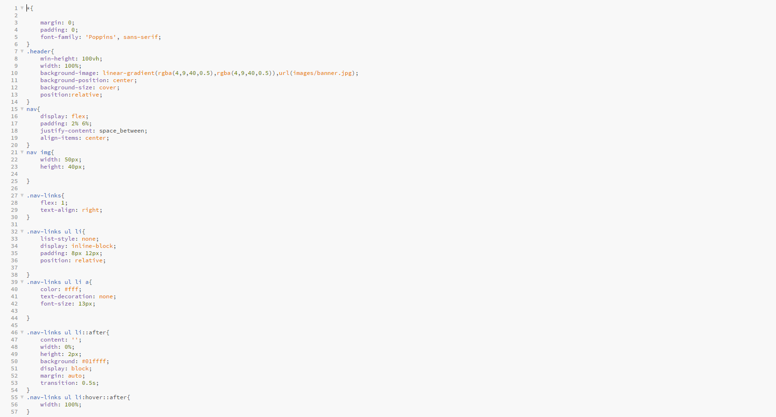

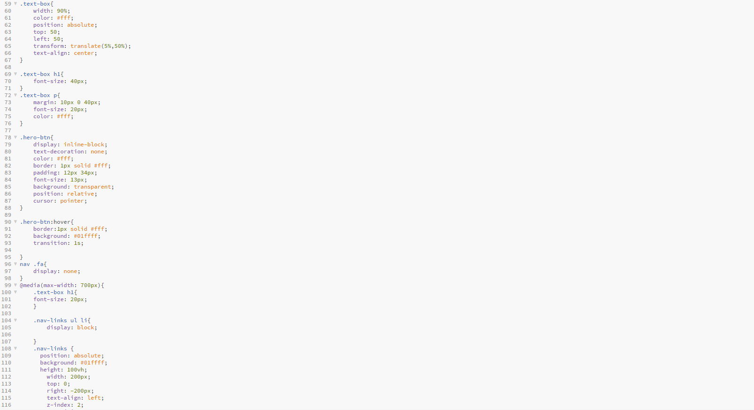

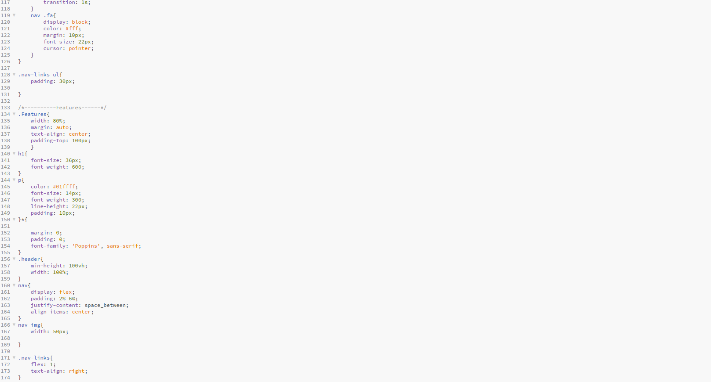

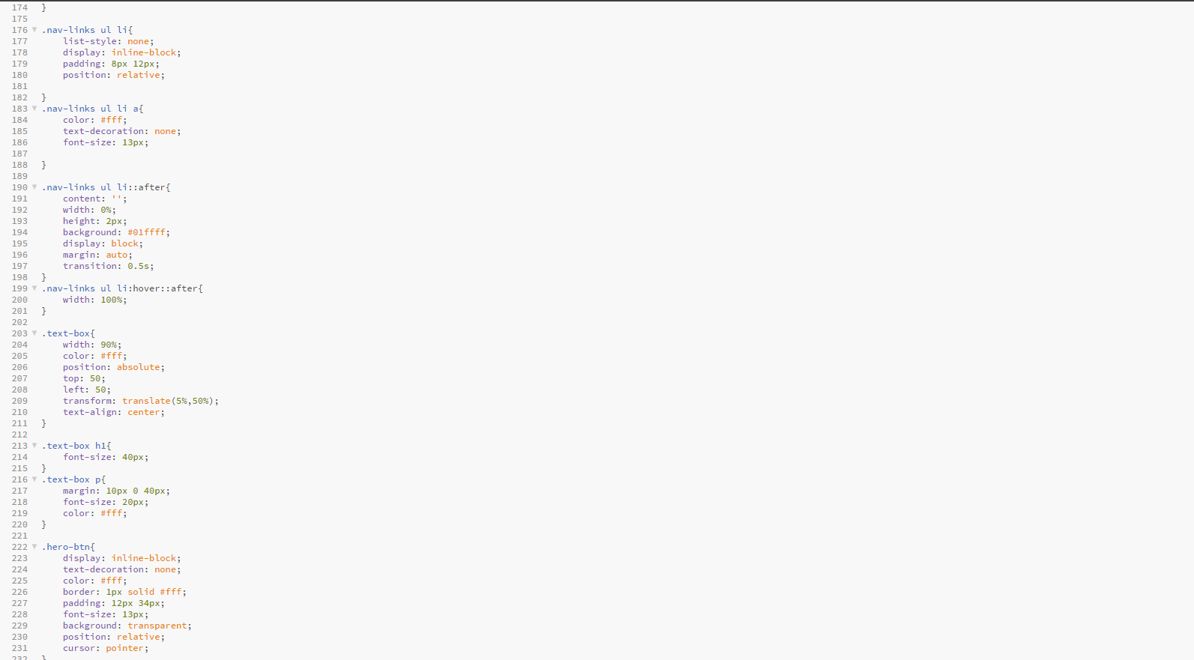

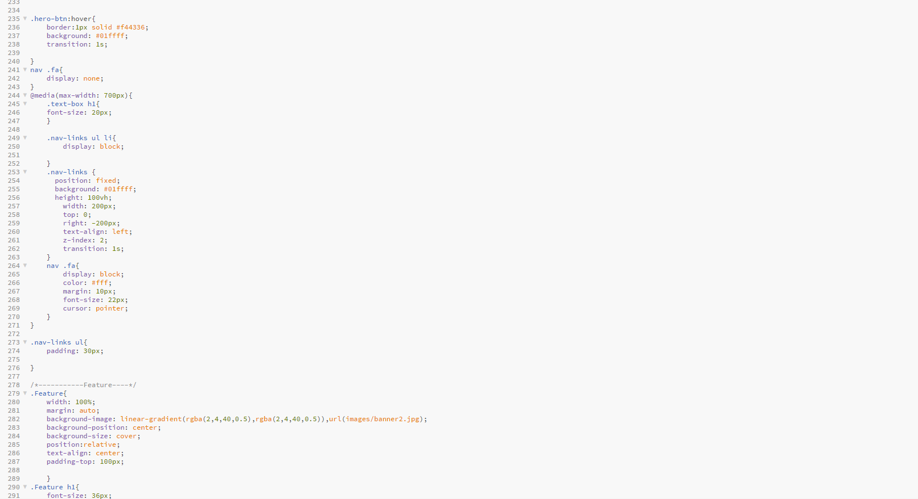

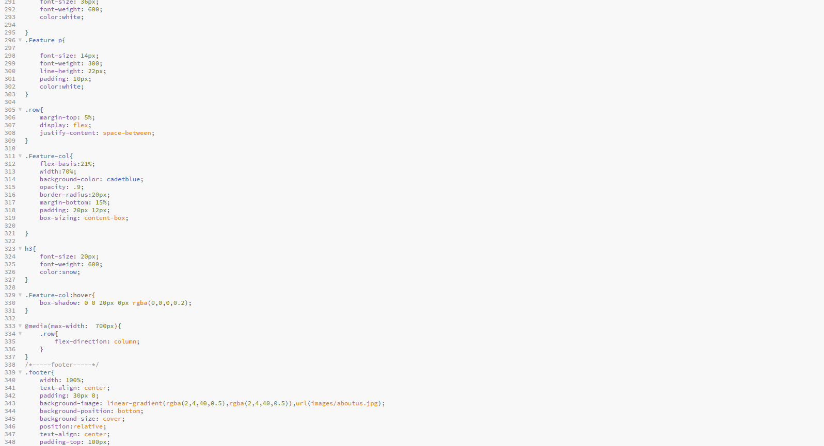

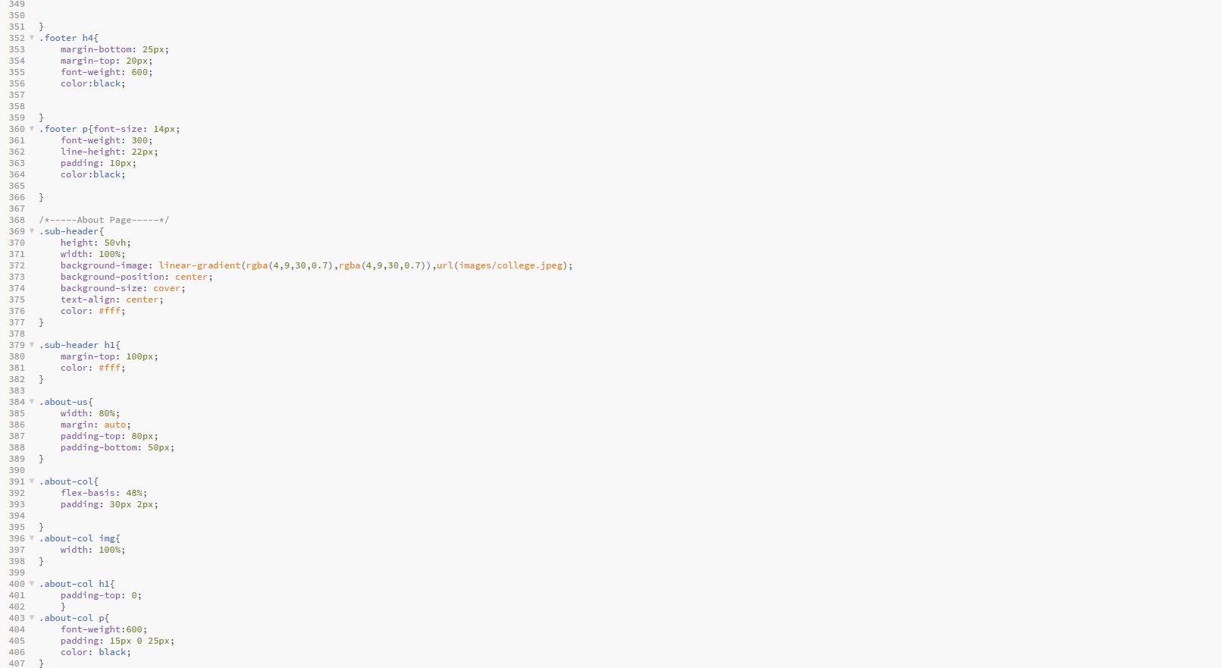

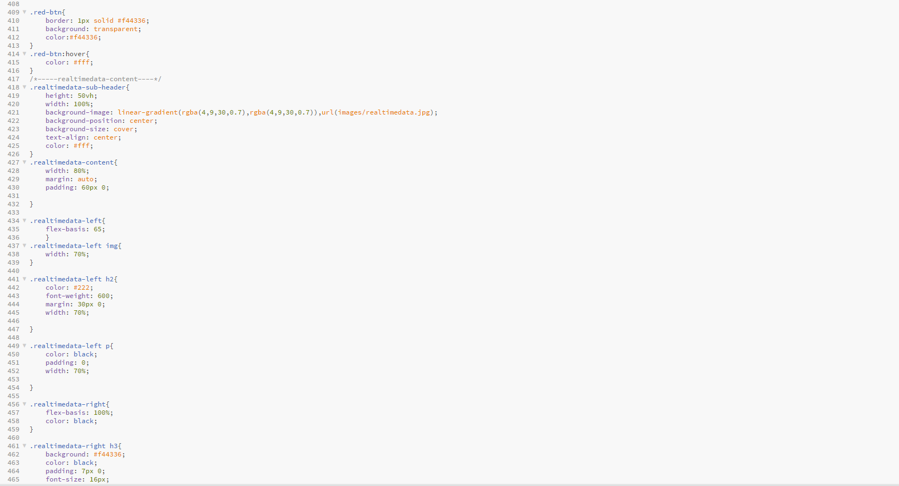

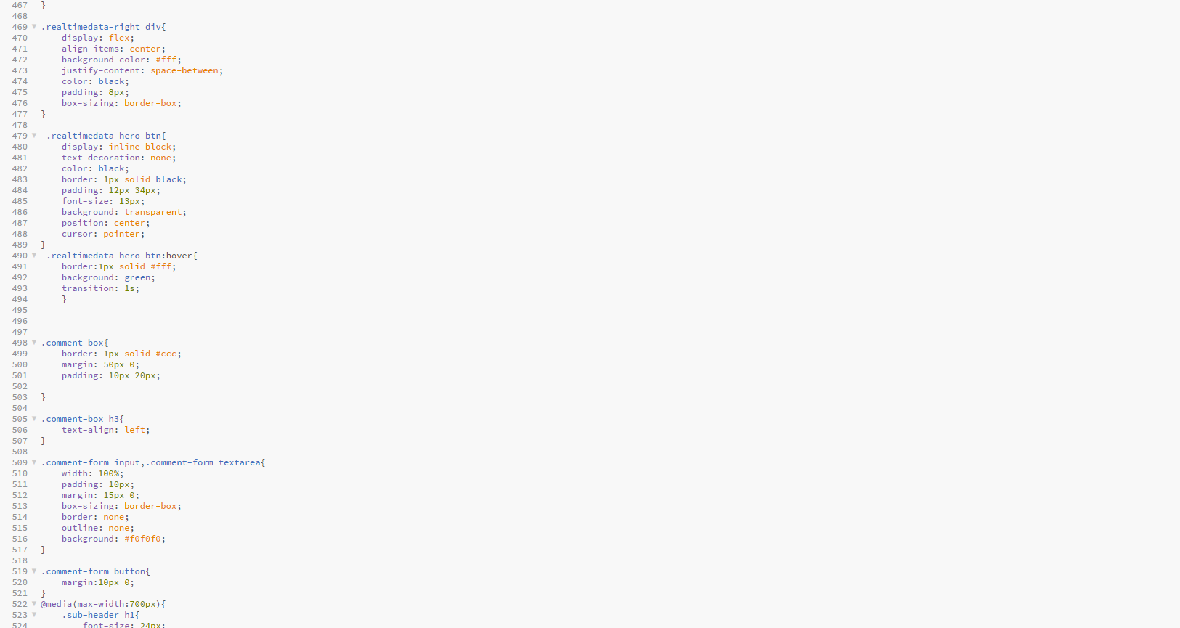

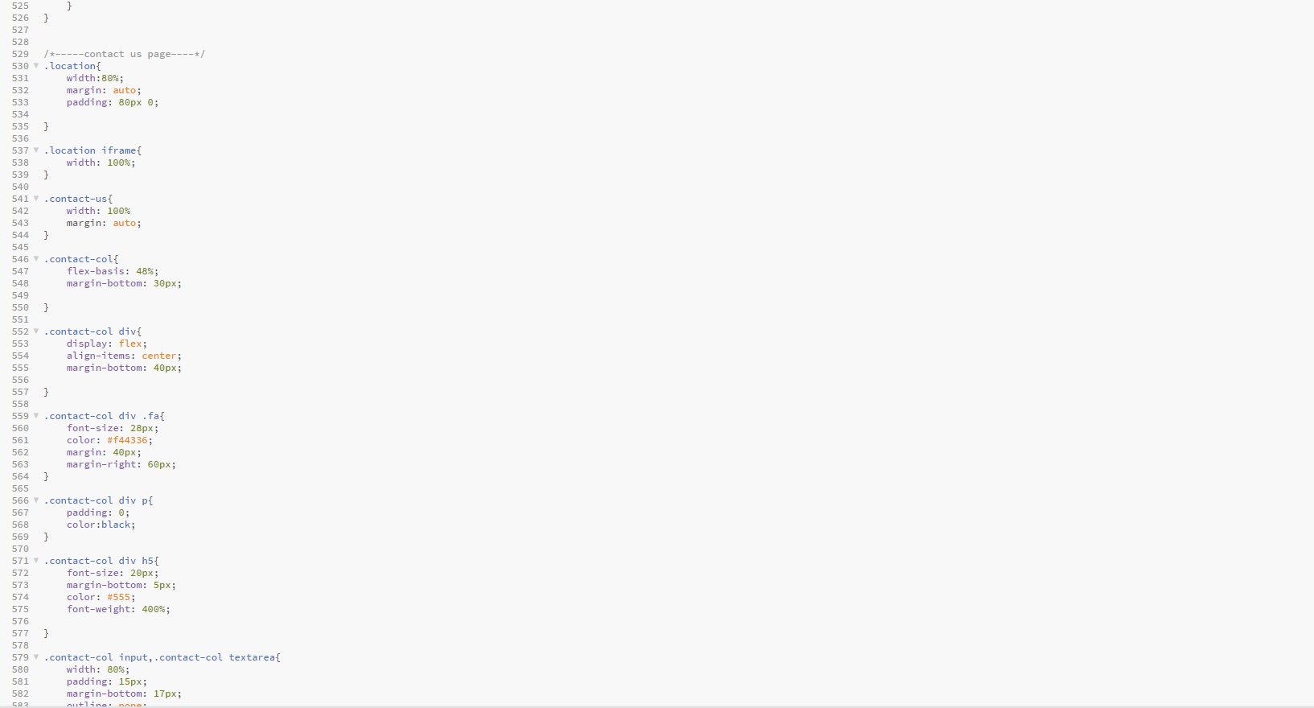

The above two steps of HTML and CSS coding has successfully enabled us to build the webpage with all necessary features and displaying the Real Time data of the park environment.

**SCREEN SHOTS OF OUR WEBSITE CREATED WITH THE ABOBE CODE:**

**INDEX PAGE:**

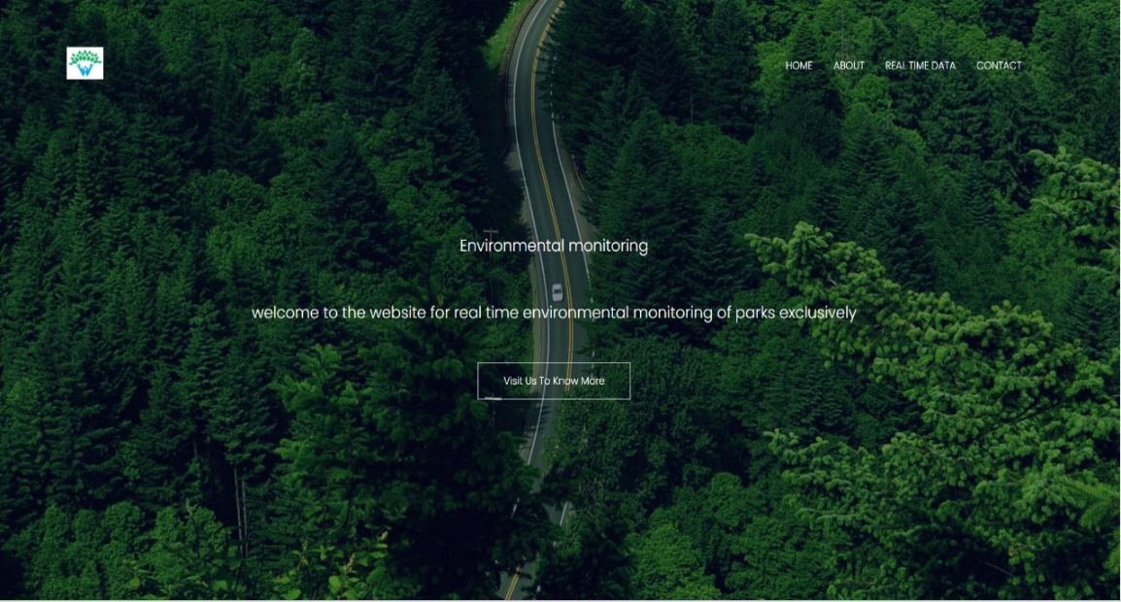

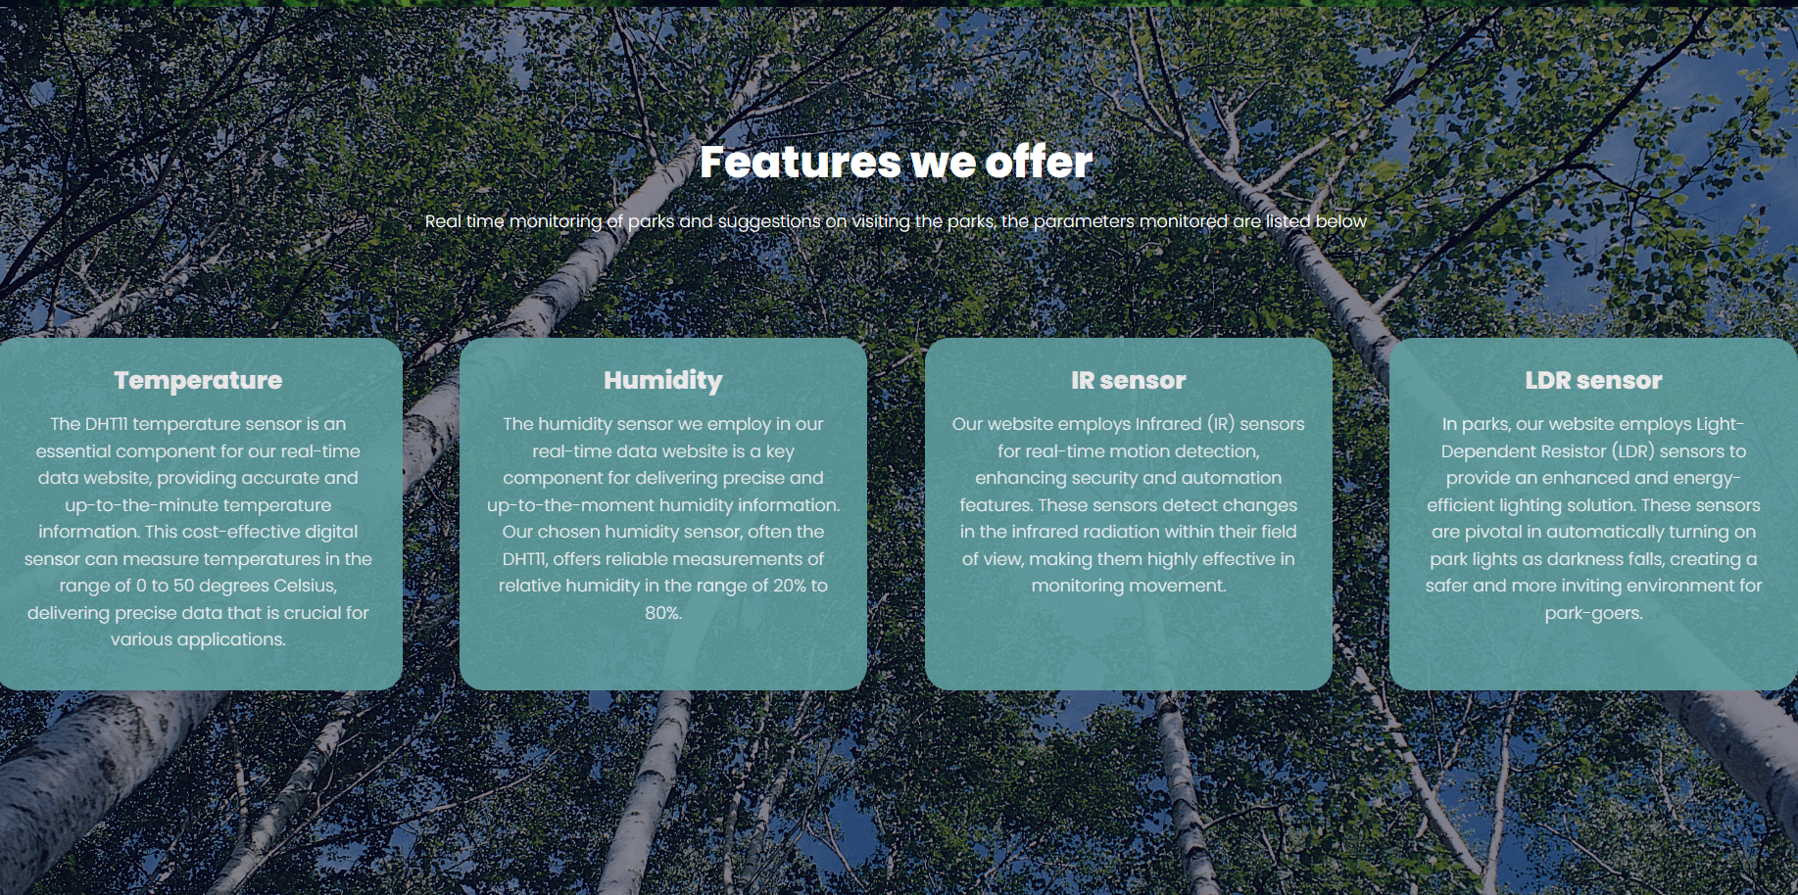

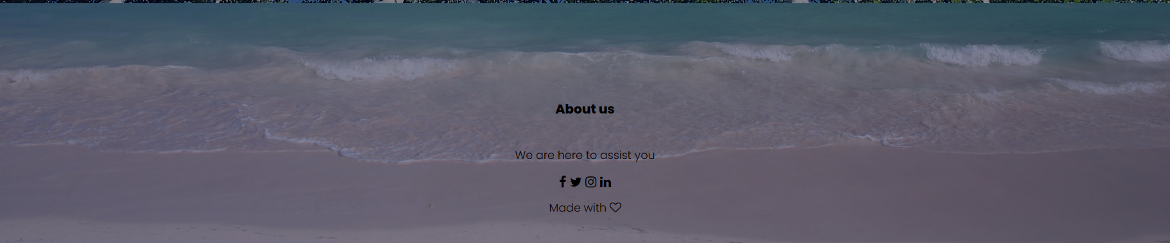

**ABOUT PAGE**

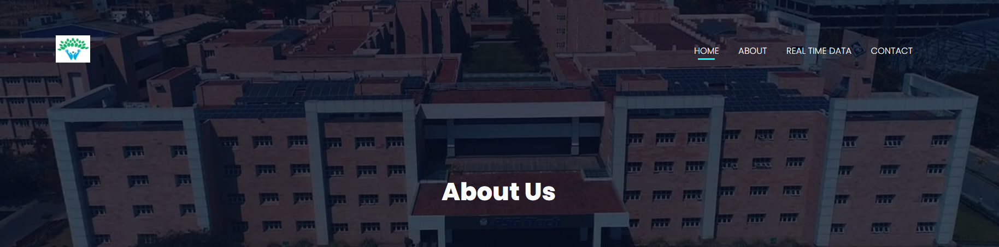

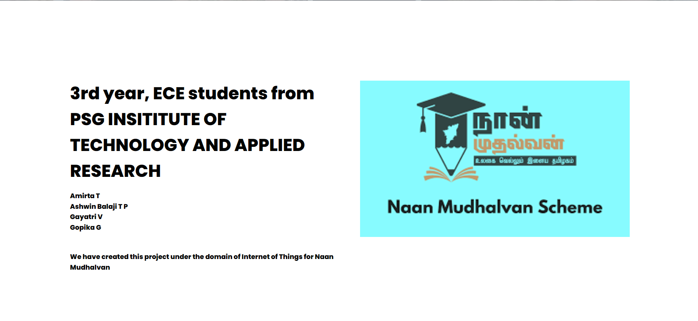

**REAL TIME DATA PAGE:**

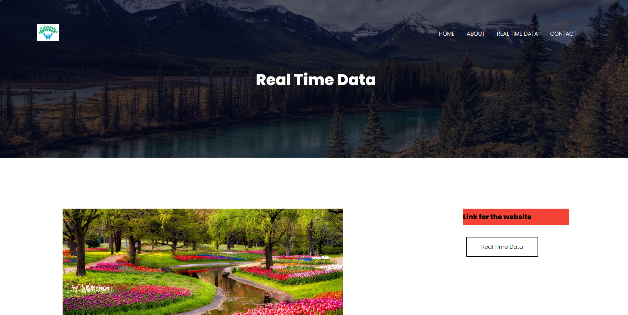

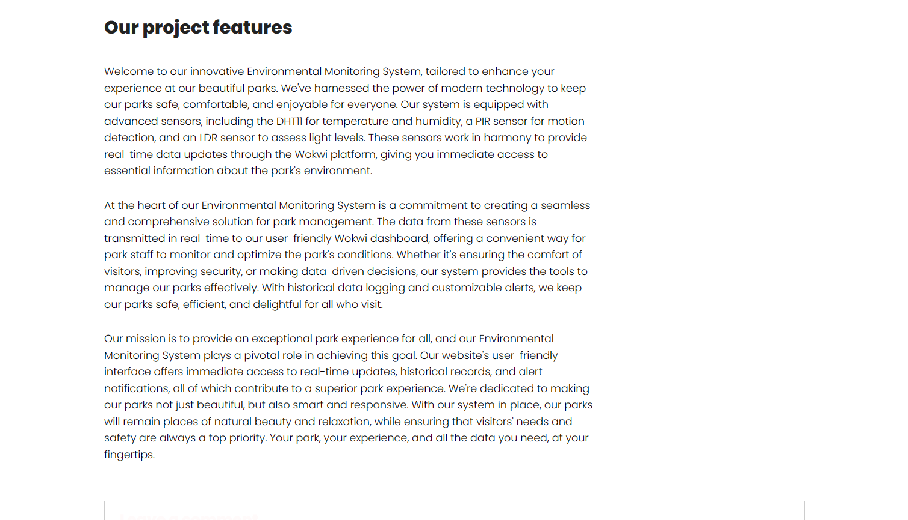

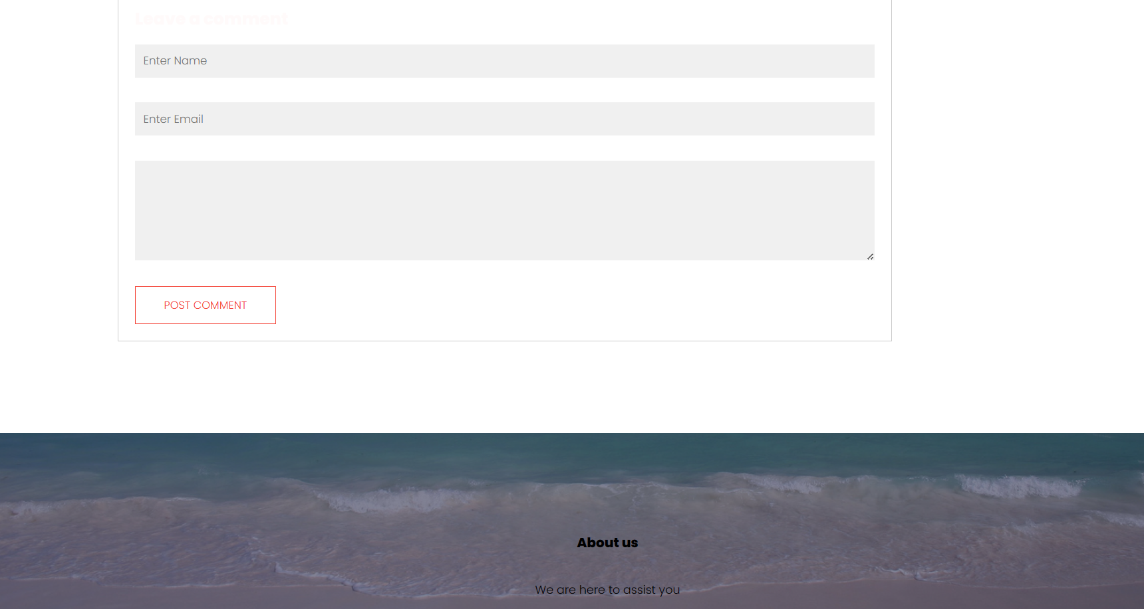

**CONTACT PAGE:**

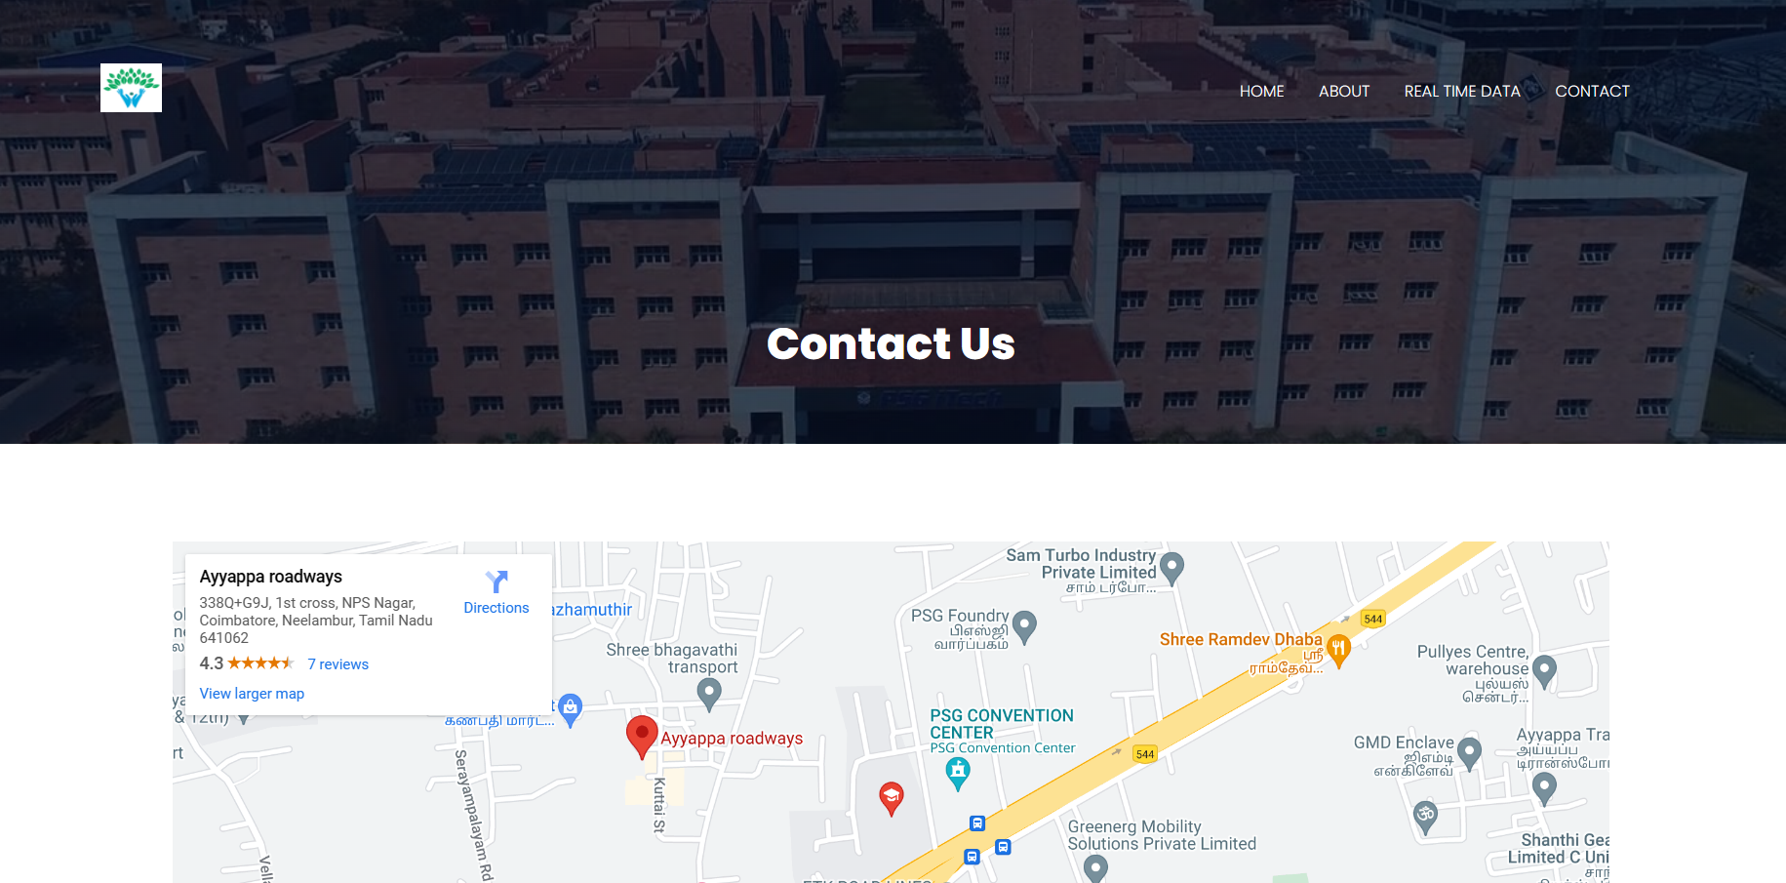

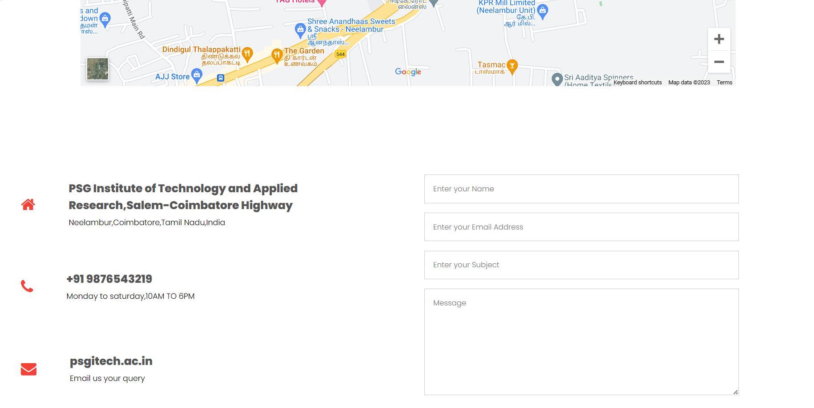

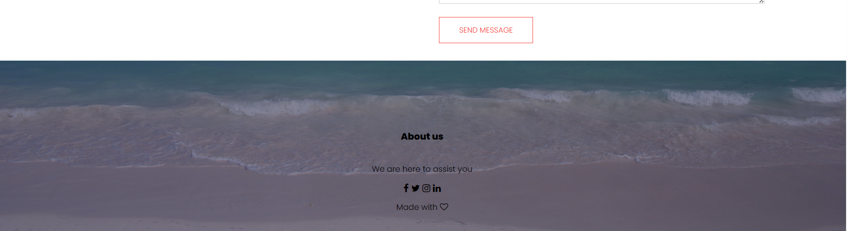

**REAL TIME DATA:**

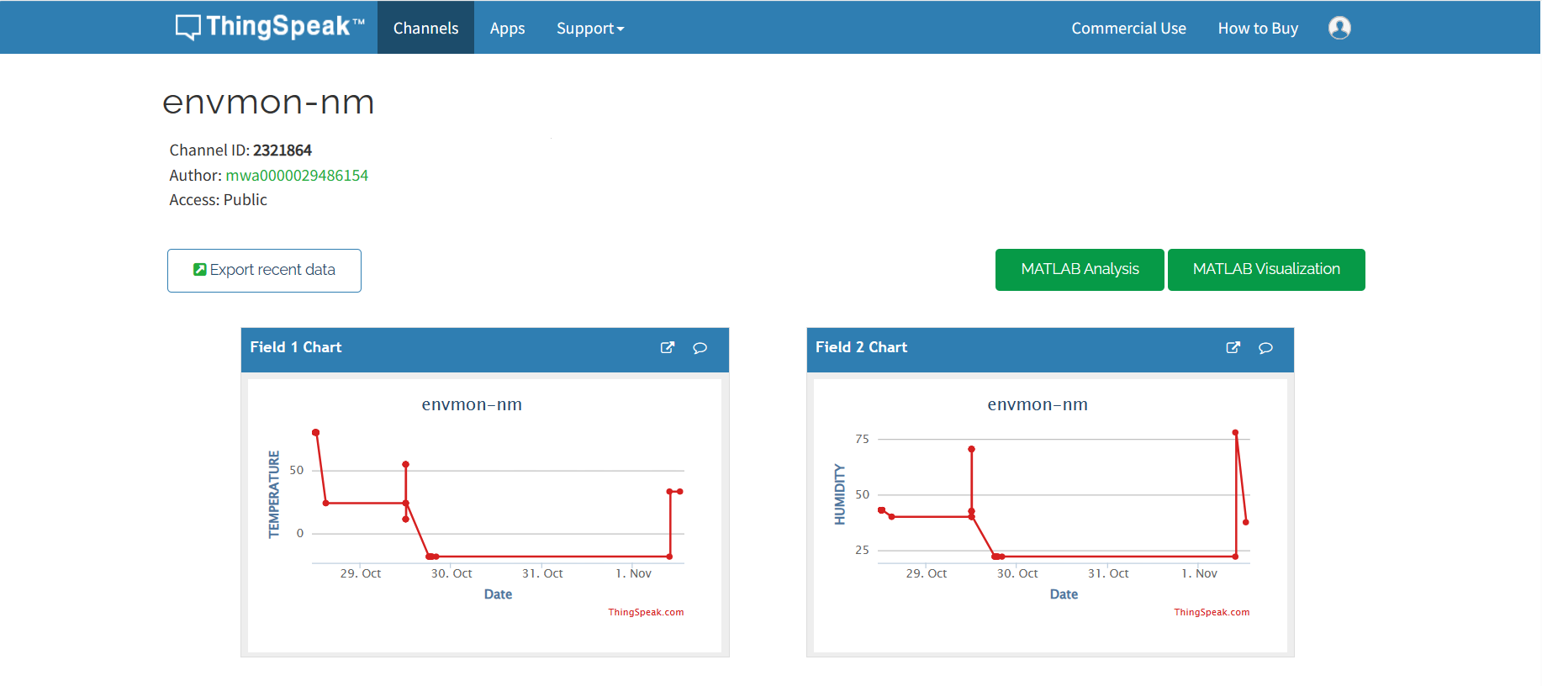

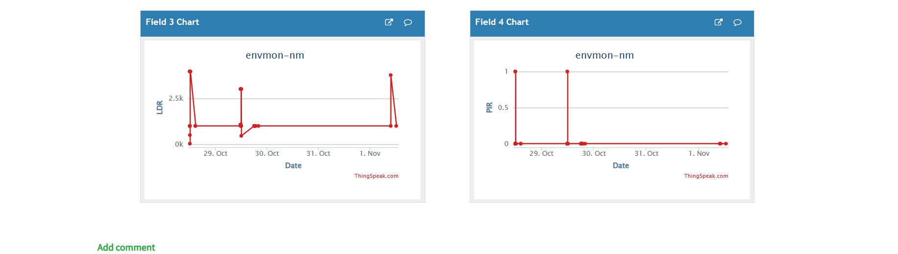

The graphs above depict the user (Park visitor) about the current environmental data of the park like the current temperature and humidity.